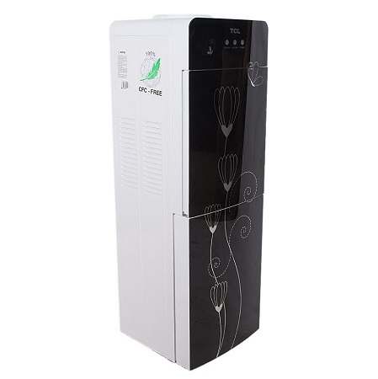

***Tcl 8k fully automatic front loading Water dispenser***

* **Color:**white/blue
* **Available:**in stock
* **Dimension:**1641*595*600
* **Size:**19
* **Old Price:**~~Rs 55,000.00~~
* **New Price:**Rs 47,500.00